Ensuring Efficient Security Log Management in ShieldSec SOC Using Binary Search Trees
Introduction
ShieldSec SOC is dedicated to ensuring robust cybersecurity through effective log management. Binary trees, as described by Morin (2013), offer a structured approach for organizing and accessing large volumes of security logs. Solution to Security Log Management in ShieldSec SOC can be addressed by exploring how binary trees facilitate efficient log storage and rapid access, details the insertion process for urgent logs, and examining the impact and optimization of deletion operations within its log management system. Figure 1 shows a possible security log binary search tree for this scenario.
Figure 1
Shield SOC security log binary search tree
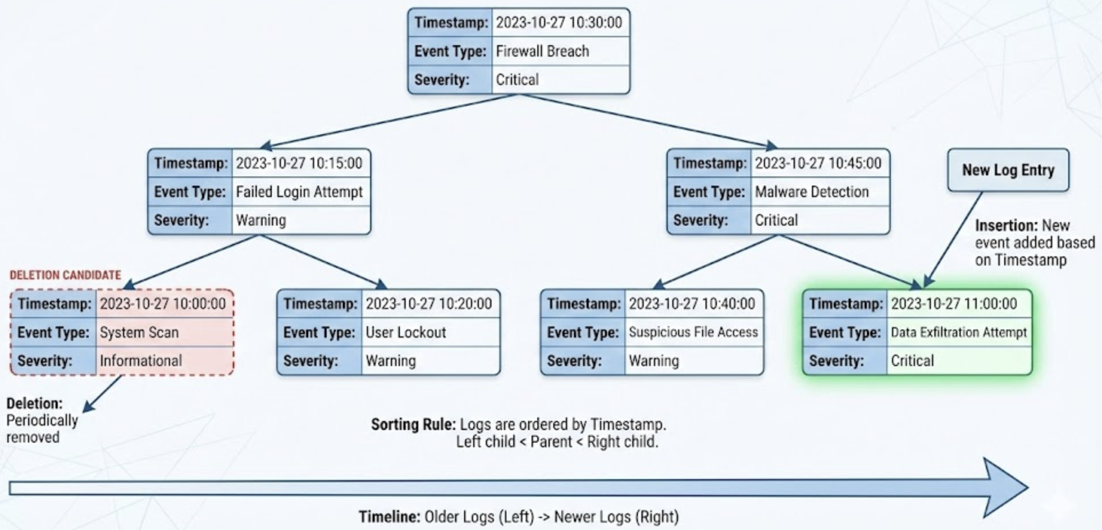

Efficient security log storage and rapid event access
ShieldSec SOC’s binary search tree (BST) model structures security logs according to their timestamps, ensuring both order and efficiency. In this system, each log entry containing its timestamp, event type, and severity is represented as a node. The root of the tree is the “Firewall Breach” event at 2023-10-27 10:30:00 (Critical). To organize the logs, older events are placed in the left subtree, while newer events occupy the right. This chronological ordering allows security analysts to quickly find specific logs: for example, retrieving the “Malware Detection” event at 2023-10-27 10:45:00 requires traversing right from the root, following the timestamp order. As log searches follow this structured path, access speed depends on the tree’s height rather than the total number of logs, guaranteeing rapid retrieval of high-priority events even as the system scales.

Insertion process: Adding urgent security logs
When ShieldSec detects a potential breach, such as a “Data Exfiltration Attempt” at 2023-10-27 11:00:00 (Critical), the BST’s insertion process ensures efficient integration. Starting at the root (“Firewall Breach” at 10:30:00), the system compares the new log’s timestamp. Since 11:00:00 is newer than 10:30:00, traversal moves right to the “Malware Detection” node at 10:45:00. Because 11:00:00 is also later than 10:45:00, the new log is inserted as the right child of “Malware Detection,” preserving the BST’s chronological order. This approach supports real-time updates without disrupting the tree’s structure, enabling immediate availability of urgent security events for fast response.

Deletion and optimization: Maintaining performance
To avoid system overload and comply with retention policies, ShieldSec SOC periodically deletes older or less critical logs. For instance, the “System Scan” at 2023-10-27 10:00:00 (Informational) is a candidate for removal. The system locates this node in the leftmost branch of the tree. If the node is a leaf, as in this case, it is directly removed. If the node had children, its child would be spliced into its position. By pruning outdated logs from the left subtree, ShieldSec maintains chronological structure and prevents imbalance, ensuring the tree remains optimized for ongoing threat detection and log management.

Conclusion
Employing a BST for security log management allows ShieldSec SOC to efficiently store, rapidly retrieve, and systematically update logs. By strictly ordering entries by timestamp as shown in Figure 1 the system guarantees fast access to critical security events, smooth integration of new logs, and effective deletion of old data. This structured approach bolsters ShieldSec’s resilience against evolving cyber threats and supports real-time, scalable operations.

Reference
Morin, P. (2013). Open data structures: An introduction. Athabasca University Press.

